**Project book – DPD**

# **Digital Predistortion for High Efficiency Power Amplifier Architecture Using a Dual-Input Modeling Approach**

## **Introduction:**

To achieve high average power added efficiency (PAE) with high peak-to-average-power-ratio (PAPR), a various power amplifier (PA) architectures have been introduced. Two promising methods are:

1. Envelope tracking (ET)
2. Varactor-based dynamic load modulation (DLM)

These architectures maintain high efficiency over a wide range of output power by dynamically control the DC supply and load impedance along with the input power. Two important problems that needs to be considered in practice are:

1. The envelope signal bandwidth is usually 3-4 times bigger than the bandwidth of the modulated RF signal.
2. Two input signals may be difficult to time-align properly.

Despite these problems, results are shown that by using DPD in dedicated methods, the nonlinearity can be compensated and to be overcome.

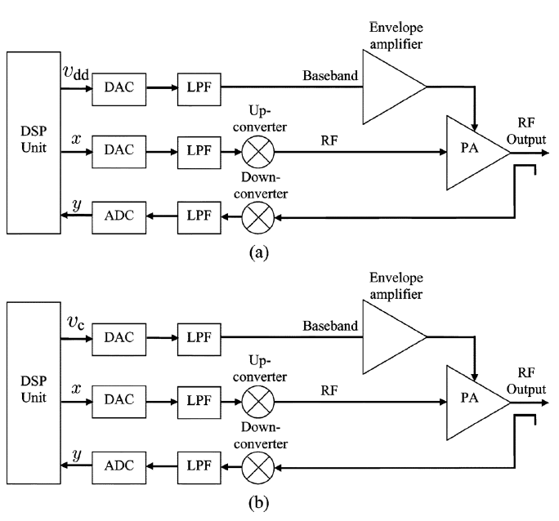Fig.1 below shows a simplified block diagrams for high-efficiency PA architectures:

**Fig.1: Simplified block diagrams for high-efficiency PA architectures**

**(a) – ET model ; (b) – DLM model**

Where the model inputs and outputs are:

* $x$ is the RF input signal
* $y$ is the output RF signal
* $v_{dd}$ and $v_{c}$ are the envelope signals for ET and DLM respectively

## **Modeling of Dual-Input PA Architecture:**

Compared to the traditional PA architectures, the dual input characteristic of the ET and DLM gives them another degree of freedom. By that, if a proper design of the RF input and envelope signal is done, the PA can achieve better linearization performance and enhanced average PAE.

**Fig.2 : General model for high-efficiency PA architecture**

Fig.2 below shows a general model for high-efficiency PA architecture:

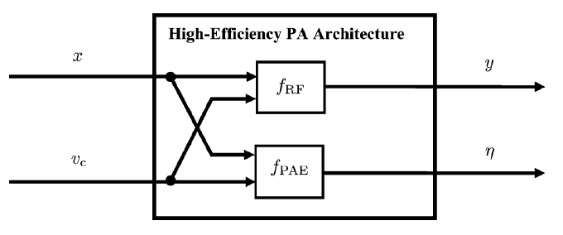

Where the model inputs, outputs and functions are:

* $x$ is the RF input signal
* $v_{c}$ is the envelope signal
* $y$ is the output RF signal
* $η$ is the instantaneous PAE
* $f_{RF}$ is the transfer function representing the RF path
* $f_{PAE}$ is the transfer function representing the output PAE path

The model equation can be written as:

$$y=f_{RF}(x,v_{c})$$

$$η=f_{PAE}(\left|x\right|, v_{c})$$

Since there are many different combinations of $x$ and $η$ which can satisfy $y$, we have the freedom of choosing the combination which gives us the highest PAE. As of that, it leads us to an optimization problem of finding the optimal RF input signal $x_{opt}$ and the optimal envelope signal $v_{c,opt}$, which can be written as:

$$\left(x_{opt}, v_{c,opt}\right)=\underset{x,v_{c}}{argmax}{f_{PAE}(\left|x\right|, v_{c})}$$

subject to: $f_{RF}\left(x, v_{c}\right)=y_{desired}$

where $y_{desired}$ is the desired output signal of the PA, and the maximum PAE and minimum distortion can achieved by jointly finding $x_{opt}$ and $v_{c,opt}$. All the mentioned above is the basis of the static model used for the existing linearization methods.

### **Derivation of a new model:**

First observation from the proposed new model, is that the predistorted signal at the RF brunch is constructed by using the information from both the baseband brunch and the RF brunch. Second, the new model driven by a two-step approach, rather than looking for the optimal input signals of the RF and the envelope jointly.

* *Step 1:* Choose the envelope signal that can maximize the average PAE.
* *Step 2:* Choose the RF input signal which minimizes the distortion between the RF output signal $y$ and the desired RF output signal $y_{desired}$.

For an appropriate envelope signal $v_{c}$, the function $f_{RF}$ that is mentioned above, can be considered as a normal transfer function for RF PAs with a one-to-one mapping between $x$ the RF input signal and $y$ the output signal. From the $p^{th}$ order inverse theory, $f_{RF}$ is normally invertible, and for a known $v_{c}$ the predistorted RF signal can be written with respect only for $x$ and $y$ as:

$$x=f_{RF}^{-1}(y, v_{c})$$

By assigning $y=y_{desired}$, $x_{opt}$ can be extracted:

$$x_{opt}=f_{RF}^{-1}(y_{desired}, v_{c})$$

To maximize the efficiency, the envelope signal must be chosen according to the function $f_{PAE}$ mentioned above. By using $x_{opt}$ it can be expressed as:

$$v_{c,opt}=\underset{v_{c}}{argmax}{f_{PAE}(\left|x_{opt}\right|, v_{c})}=\underset{v_{c}}{argmax}{f_{PAE}(\left|f_{RF}^{-1}(y_{desired}, v_{c})\right|, v_{c})}$$

Which can be written as a function of only $y_{desired}$:

$$v_{c,opt}=g(y_{desired})$$

By extracting $v_{c,opt}$ from the function $g$, its value can be assigned back to $f_{RF}^{-1}$ and $x_{opt}$ can be achieved.

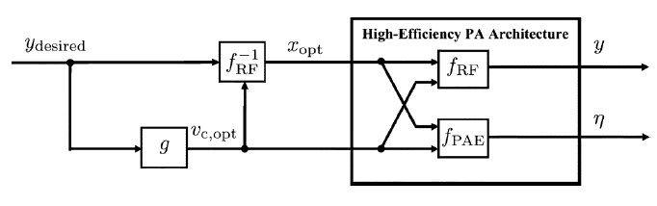Fig.3 below shows a block diagram which representing the new model for linearization high-efficiency PA architectures:

**Fig.3 : New model for linearization high-efficiency PA architectures**

## **New Dual-Input Linearization Method**

### **Behavioral Model of Efficiency-Optimized Function:**

The efficiency-optimized function $g$ that is mentioned above (and seen in Fig.3) can be polynomial modeled as:

$$v_{c}\left(n\right)=g\left(y\left(n\right)\right)=\sum_{k=0}^{K}{a_{k}{\left|y\left(n\right)\right|}^{k}}$$

Where the model key is:

* $y$ is the RF output signal
* $a_{k}$ is the model coefficient
* $K$ is the nonlinear order

To get the optimal function $g$ or the model coefficients $a$, static continues wave (CW) measurements being utilized for both input signals (the amplitude of the RF and the envelope input signal). Then, the static output amplitudes and efficiencies are being recorded, and for each output power level, the combination of both input power and envelope input signal, that produces the highest efficiency, is being used. By running through these steps, it is guaranteed that the PA can be linearized because the efficiency-optimized envelope signal $v_{c,opt}$ is chosen.

### **Behavioral Model of Linearity-Optimized Function:**

The function $f_{RF}^{-1}$ that is seen in Fig.3 can be considered as a dual-input single-output behavioral model for the high-efficiency PA architectures. By adding one real-valued dimension, which represent the envelope signal, the dual-input model can be extended from the regular single-input RF PA behavioral model. It is known that the generalized memory polynomial (GMP) model has great performance in terms of linearity Vs complexity. From all the mentioned above, $f_{RF}^{-1}$ can be written as a 2-D GMP model which based on the original GMP model:

$$x\left(n\right)=f_{RF}^{-1}\left(y\left(n\right), v_{c}\left(n\right)\right)=\sum_{n_{1}=1}^{N_{1}}{\sum_{m_{1}=0}^{M_{1}}{\sum_{m_{v}=0}^{M_{v}}{\sum_{p=0}^{P}{h_{n_{1}m_{1}m_{v},p}y_{m_{1}}{\left|y_{m_{1}}\right|}^{n_{1}}v_{c,m_{v}}^{p}}}}}+\sum_{n_{2}=1}^{N_{2}}{\sum_{m_{2}=0}^{M_{2}}{\sum_{l_{1}=1}^{L_{1}}{\sum_{m_{v}=0}^{M_{v}}{\sum_{p=0}^{P}{h_{n_{2}m_{2}l_{1}m_{v},p}y_{m_{2}}{\left|y_{m_{2}+l_{1}}\right|}^{n_{2}}v_{c,m_{v}}^{p}}}}}}+\sum_{n_{3}=1}^{N_{3}}{\sum_{m_{3}=0}^{M_{3}}{\sum_{l_{2}=1}^{L_{2}}{\sum_{m_{v}=0}^{M_{v}}{\sum_{p=0}^{P}{h_{n_{3}m_{3}l_{2}m_{v},p}y_{m_{3}}{\left|y_{m_{3}-l_{2}}\right|}^{n_{3}}v_{c,m_{v}}^{p}}}}}}$$

Where the model key is:

* $h$ are the model coefficients for the 2-D GMP model
* $N$ is the nonlinear order
* $L$ is the lagging/leading memory depth
* $M$ is the RF input signal memory depth
* $P$ is the nonlinear order for the envelope signal $v_{c}$
* $M_{v}$ is the envelope signal memory depth
* $y_{m}$ is the RF output signal with delay $m$, $y(n-m)$
* $v_{c,m_{v}}$ is the envelope signal with delay $m_{v}$, $v_{c}\left(n-m_{v}\right)$

This new model, which also has the input of the envelope signal, takes both of its inputs into consideration when building the predistorted RF input signal. As of that, even if when getting the optimal envelope signal there were some fitting errors, this new model can take their effects into account and compensate for them. In addition to that, since the output signal is still linear with respect to the model coefficients, the conventional least squares method can still be used in order to identify the dual-input behavioral model.

### **Bandwidth Reduction of the Envelope Signal:**

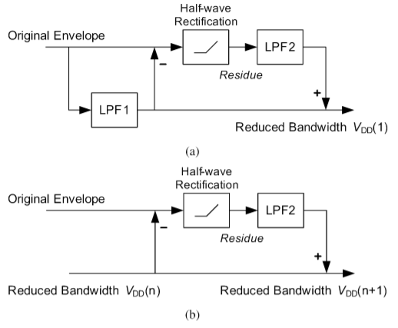The fact that the envelope signal bandwidth is larger in ET and DLM is causing a major challenge for the hardware designers. Some methods for reducing the bandwidth shows promising results. However, these methods can’t be used directly in the current linearization architectures, since the RF predistorted input signal doesn’t have knowledge of the envelope signal. So, when changing the envelope signal bandwidth, the existing methods are not linear optimal anymore. In the new model, a chosen bandwidth reduction method has been used[1], its presented in Fig.4 below:

**Fig.4 : Bandwidth Reduction method**

**(a) – Initial pass ; (b) –Iterative algorithm**

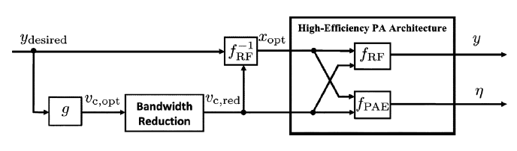It is worth mentioning that the reduced bandwidth envelope signal might cause additional memory effect to the PA. However, the proposed model is built with respect to an envelope signal with memory and can mitigated these memory effects. From that, it should be noted that the predistorted RF input signal is still optimal in terms of linearity, but the average PAE might be degraded as of the fact that the envelope optimized signal is not necessarily the same as the one with the reduced bandwidth. Fig.5 below shows a modified block diagram for the new model:

**Fig.5 : New model for linearization high-efficiency PA architectures with bandwidth reduction for envelope signal $v_{c,opt}$**

### **Complexity:**

Since the number of coefficients of the dual-input model increases according to $P$ and $M_{v}$, it has $M_{v}(P+1)$ more coefficients than a regular DPD (for example the one presented in a different article[2]). However, from experiments which was made, to get good linearization results, $P$ and $M_{v}$ needs only low orders ($0≤P,M_{v}≤2$) in the new model. As of that, the extra complexity is fairly reasonable.

# **Memory Polynomial**

Since RF-PA’s and transmitters are generally considered to be nonlinear devices that simultaneously adopt nonlinear memory effects, the Volterra series is the most comprehensive behavioral model which describes them[3]. However, the Volterra series is considered to have a large complexity in implementation, which makes it less attractive to use with. The models of the memory polynomial are a compact version of the Volterra series, which makes them far more attractive to use when looking for a way to behavioral model RF-PA’s and transmitters which suffer from memory effects. One of the models that was extracted out from the memory polynomial is the Generalized Memory Polynomial (GMP), its relation between its input and output can be written as follow:

$$y_{GMP}\left(n\right)=\sum_{m=0}^{M_{a}}{\sum_{k=1}^{K_{a}}{a_{mk}x\left(n-m\right){\left|x\left(n-m\right)\right|}^{k-1}}}+\sum_{m=0}^{M_{b}}{\sum_{k=2}^{K_{b}}{\sum_{p=1}^{P}{b_{mkp}x\left(n-m\right){\left|x\left(n-m-p\right)\right|}^{k-1}}}}+\sum_{m=0}^{M_{c}}{\sum_{k=2}^{K_{c}}{\sum_{q=1}^{Q}{c_{mkq}x\left(n-m\right){\left|x\left(n-m+q\right)\right|}^{k-1}}}}$$

The first polynomial is representing the time-alignment input signal samples, which has a nonlinearity order of $K_{a}$ and memory depth of $M_{a}$. The second and third polynomials represents the lagging and leading (respectively) between the input signal and its envelope up until the orders of $P$ and $Q$ (respectively). It should be noted that typically, the nonlinear order and the memory depth of the lagging and leading polynomials (i.e. $M_{b}, M_{c}, K_{b}, K_{c}$) are significantly lower then the orders of the time-alignment polynomial (i.e. $M_{a}, K_{a}$). Moreover, the cross-terms orders of the lagging and leading polynomials (i.e. $P, Q$), is usually relatively low. The GMP model is justifying the use of it, and the extra complexity which associated with it, when the device under test (DUT) is suffering from a strong nonlinear memory effects.

**Singla Creation – using RMC LTE generator**

## The LTE Tooldbox in Matlab was used to generate a simulated input signal with desired parameters (e.g. bandwidth, center frequency, etc..)

## We modified the script that can be found at “[Release 12 Downlink Carrier Aggregation Waveform Generation](https://www.mathworks.com/help/lte/examples/release-12-downlink-carrier-aggregation-waveform-generation-demodulation-and-analysis.html)” and managed to aggregate 4 identical signals , with 20MHz bandwidth each, to create a signal with 80Mhz bandwidth. The parameters of each aggregated signal are:

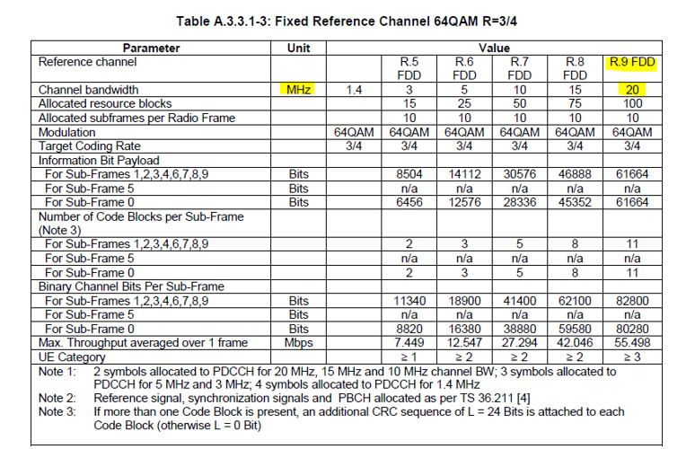

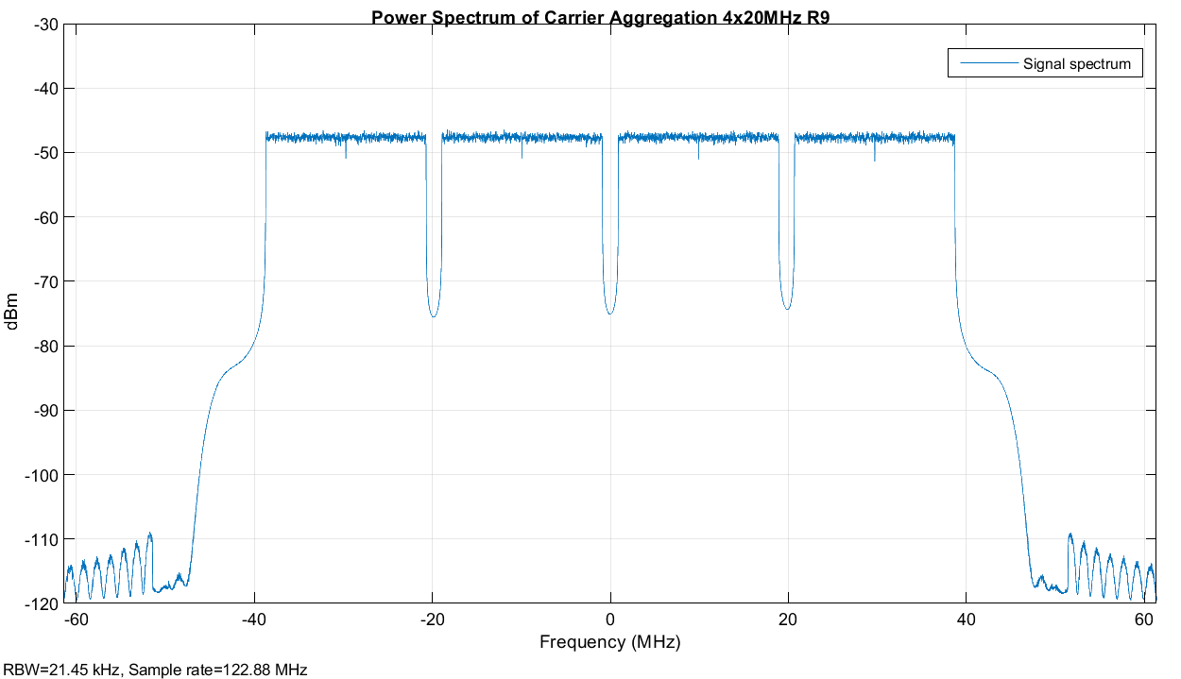The generated signal was saved in a .mat file and then was used as an input for the DPD algorithm for simulation purposes.

1. **Taken from:** J. Jeong, D. F. Kimball, M. Kwak, C. Hsia, P. Draxler, and P. M. Asbeck, “Wideband envelope tracking power amplifiers with reduced bandwidth power supply waveforms and adaptive digital predistortion techniques,” *IEEE Trans. Microw. Theory Tech.*, vol. 57, no. 12, pp. 3307–3314, Dec. 2009.
2. H. Cao, H. M. Nemati, A. S. Tehrani, T. Eriksson, and J. Grahn,“Linearization of efficiency-optimized dynamic load modulation transmitter architectures,” *IEEE Trans. Microw. Theory Tech.*, vol. 58, no. 4, pp. 873–881, Apr. 2010.
3. Behavioral Modeling and Predistortion of Wideband Wireless Transmitters, First Edition. Fadhel M. Ghannouchi, Oualid Hammi and Mohamed Helaoui. © 2015 John Wiley & Sons, Ltd. Published 2015 by John Wiley & Sons, Ltd.